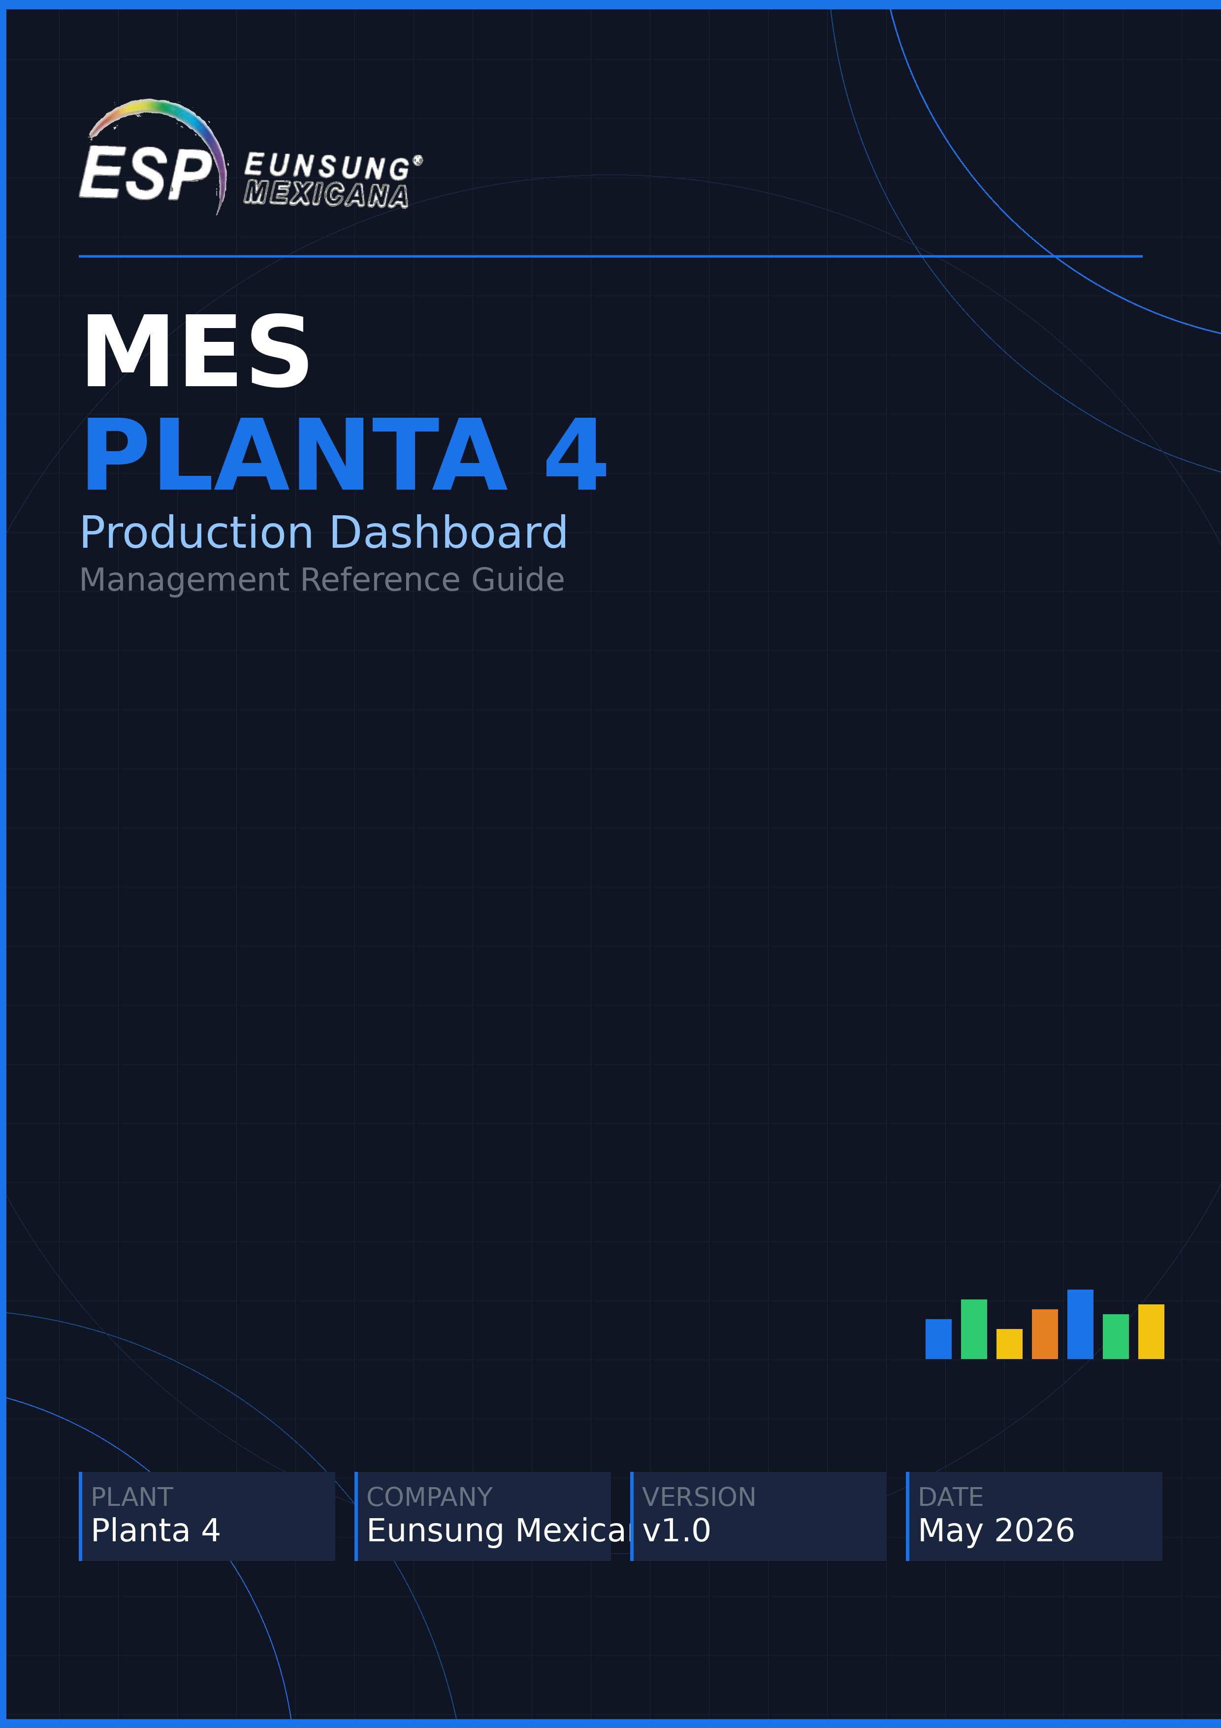

1. System Overview
What is MES and who uses it

MES (Manufacturing Execution System) captures real-time Samsung packaging production data from Planta 4. Operators enter output each shift. Supervisors and management see live charts and tables instantly.
URL: https://mes-production-esp.web.app

User Roles  ● Operator Captures production, defects & scrap per shift  ● Supervisor Views full live dashboard and charts  ● Admin Full access — users, machines, targets | Shift Schedule — Cortes  ■ Break (C1) 7:00 – 8:45 AM  ■ Lunch (C2) 9:00 – 12:30 PM  ■ Home (C3) 1:00 – 4:30 PM  ■ OT 4:45 – 6:25 PM

2. KPI Summary Bar
Five key indicators always visible at the top of the dashboard

PRODUCTION | COMPLIANCE | SCRAP % | DEFECTS % | DOWNTIME
Total units built today | % of daily target hit | % of units discarded | % with quality issues | Total min. stopped
Higher = better | Target: >= 100% | Target: < 0.5% | Target: < 1% | Target: < 10 min

3. Compliance by Machine
How close each machine is to its daily production target

Compliance by Machine
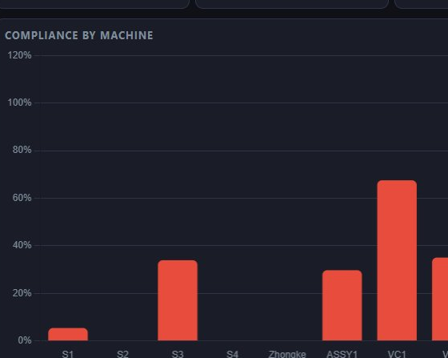 | ● Each bar = one machine. Height = % of target achieved.  ✅ >= 100% — On or over target. No action needed.  ⚠ 80 – 99% — Slightly behind. Monitor closely.  🔴 < 80% — Alert. Request recovery plan from supervisor.  ▶ In the example: most machines are below 80% — this is a low-production day.

4. Production by Cut
Units produced per machine, broken down by shift period

Production by Cut
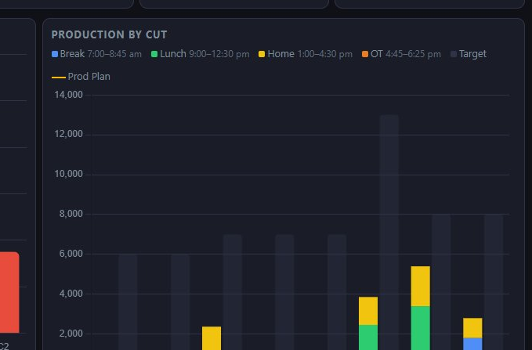 | ● Stacked bars show production by time period (corte).  ■ Blue=Break · Green=Lunch · Yellow=Home · Orange=OT  ● Dark gray bar = Target. Orange dashed line = Prod Plan.  ✅ Total bar reaches dark bar → machine met its target.  🔴 Total bar below dark bar → machine is behind plan.

5. Machine Detail Table
Row-by-row performance summary for every machine

Machine Detail
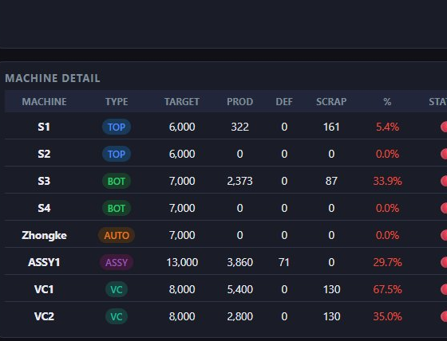 | ● One row per machine: Target → Prod → Def → Scrap → % → Status.  ● TARGET = planned units. PROD = actual built. DEF = defective.  ✅ Status OK = machine within acceptable performance range.  ⚠ Warning = attention needed — clarify cause with supervisor.  🔴 % below 80% on any machine → immediate follow-up required.

6. Downtime Detail Table
Every stoppage recorded during the current shift

Downtime Detail
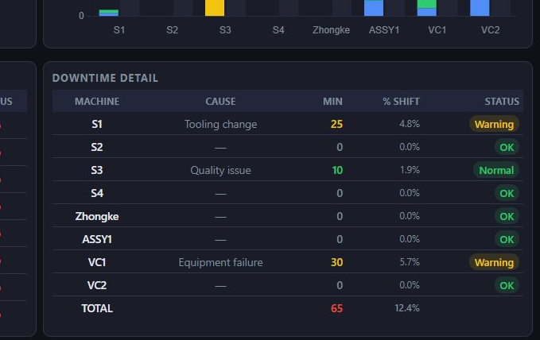 | ● Each row = one stop event: cause, minutes lost, % of shift.  ● CAUSE: operator-reported reason (Tooling change, Equipment failure…).  ✅ OK = no stop or < 5% of shift. Normal = minor brief stop.  ⚠ Warning = significant stop. Review maintenance log.  🔴 > 10% downtime on any machine → escalate immediately.

7. Production Summary · Model & Parts
Every Samsung model produced today — full detail per machine

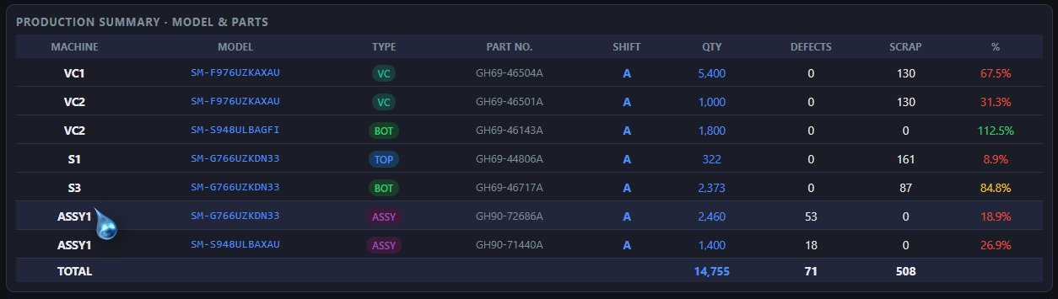

MACHINE | MODEL | TYPE | PART NO. | QTY | DEF / SCRAP | %
VC1, VC2, S1… | SM-XXXXXXXXX | TOP/BOT/VC/ASSY | GHxx-XXXXX | Units built | Failed / discarded | Compliance

8. Material Ready for ShipQR · P4 → P3
Finished goods ready to transfer to Planta 3

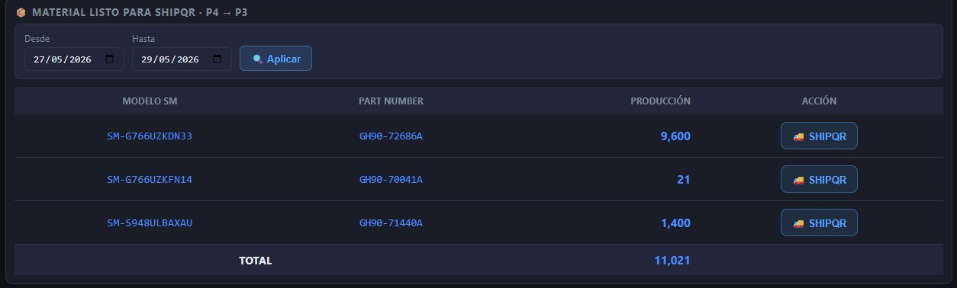

Lists every completed model and part number ready for transfer to Planta 3. Filter by date range. Click SHIPQR to confirm the shipment.

9. Key Metrics — Thresholds
Reference values for evaluating daily performance

Metric | ✅ Acceptable | ⚠ Warning | 🔴 Critical
Compliance % | >= 100% | 90 – 99% | < 80%
Defects % | < 1% | 1 – 3% | > 3%
Scrap % | < 0.5% | 0.5 – 1% | > 1%
Downtime | < 5% of shift | 5 – 10% | > 10%

10. Daily Production Targets
Planned output per machine per day

Machine | Description | Daily Target
S1 / S2 | Sealing machines 1 & 2 — TOP / BOT packaging | 7,000 pcs
S3 / S4 | Sealing machines 3 & 4 — BOT packaging | 9,000 pcs
Zhongke | Zhongke sealing line — AUTO packaging | 7,000 pcs
VC1 | Vacuum chamber line 1 — VC packaging | 8,000 pcs
VC2 | Vacuum chamber line 2 — VC packaging | 8,000 pcs
ASSY1 | Final assembly line — ASSY packaging | 13,000 pcs

11. Contact & Support

System Administrator | Octavio (Tavox) tvxesp963@gmail.com
Dashboard URL | https://mes-production-esp.web.app

